**DevOps Balachandran K K**

**22ISR005**

**Task 4**

Create a Kubernetes deployment in Minikube, define and apply deployment and service configurations in file.txt and expose.txt and expose the service to match the deployment pod label.

1. Open file.txt and adding Deployment YAML.

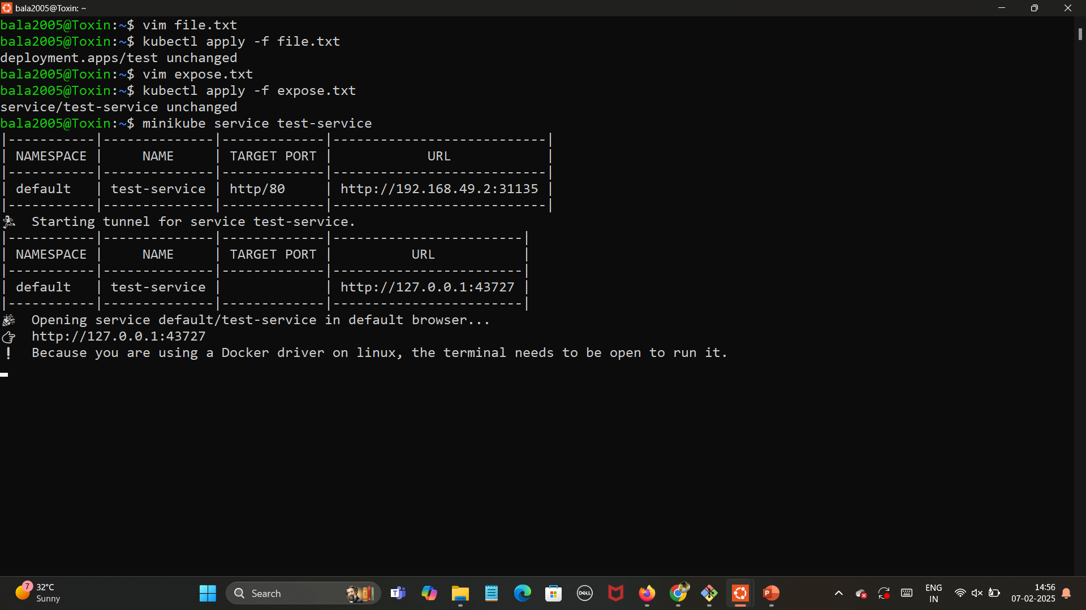

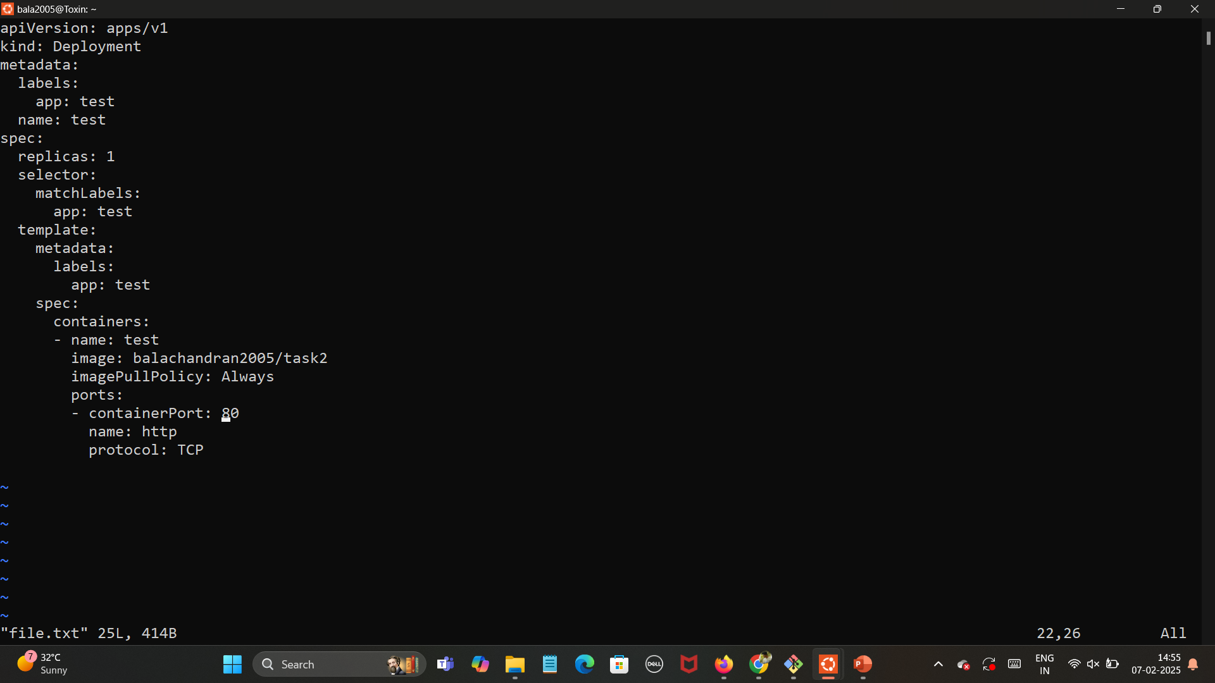

1. Open expose.txt and adding Service YAML.



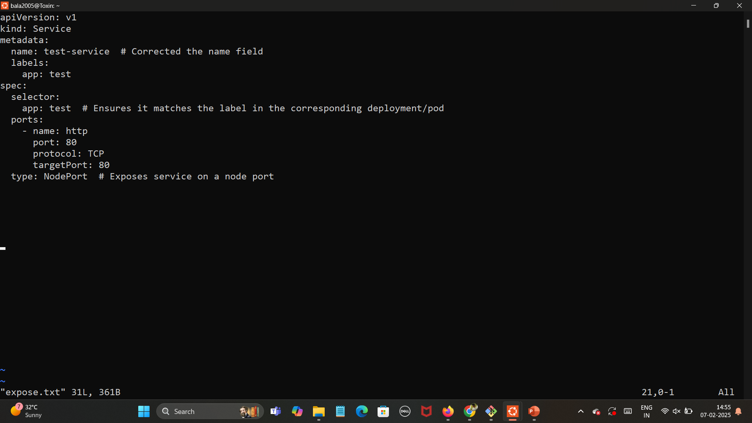

1. Finding the Minikube Service URL.



1. Final Output in the URL <http://127.0.0.1:43727>

